/*
Neeti Kurulkar
SE Div: A Batch: S2
Roll No. : 21038
DSAL Practical Assignment 12

Department maintains a student information. The file contains roll number, name, division and address.
Allow user to add, delete information of student. Display information of particular employee. If record
of student does not exist an appropriate message is displayed. If it is, then the system displays the
student details. Use sequential file to main the data.
*/

#include <iostream>
#include <fstream>
#include <string>
#include <vector>
using namespace std;

class Student {
private:
string roll_number;
string name;
string division;
string address;

public:
Student(){}
// Constructor
Student(const string& roll, const string& n, const string& div, const string& addr)
: roll_number(roll), name(n), division(div), address(addr) {}

// Function to add student information to the file
void addStudent() {
ofstream file("student_info.txt", ios::app);
if (file.is_open()) {
file<<roll_number;
file <<"\nRoll Number : "<< roll_number << "\n" <<"Name : " <<name << "\n" << "Division : "<<division << "\n" <<"Address : "<< address << "\n\n";
cout << "Student information added successfully." << endl;
} else {
cerr << "Unable to open file." << endl;
}
}

// Function to delete student information from the file
void deleteStudent() {
ifstream inFile("student_info.txt");
ofstream tempFile("temp.txt");
int flag = 0;
string line;
bool found = false;
while (getline(inFile, line)) {
if (line.substr(0, roll_number.size()) != roll_number && flag == 0) {
tempFile << line << endl;
} else {
found = true;
flag += 1;
if(flag==6)
flag = 0;
}
}

inFile.close();
tempFile.close();

remove("student_info.txt");
rename("temp.txt", "student_info.txt");

if (found) {
cout << "Student information deleted successfully." << endl;
} else {
cout << "Student not found." << endl;
}
}

// Function to display student information
void displayStudent() {
ifstream file("student_info.txt");
string line;
while (getline(file, line)) {
cout<<line<<endl;
}
}

};

int main() {
while (true) {
cout << "\n1. Add Student\n2. Delete Student\n3. Display Student\n4. Exit\n";
cout << "Enter your choice: ";

int choice;
cin >> choice;

switch (choice) {
case 1: {
string roll_number, name, division, address;
cout << "Enter Roll Number: ";
cin >> roll_number;
cout << "Enter Name: ";
cin.ignore();
getline(cin,name);
cout << "Enter Division: ";
cin >> division;
cout << "Enter Address: ";
cin.ignore();
getline(cin,address);
Student newStudent(roll_number, name, division, address);
newStudent.addStudent();
break;
}
case 2: {
string roll_number;
cout << "Enter Roll Number to delete: ";
cin >> roll_number;
Student studentToDelete(roll_number, "", "", "");
studentToDelete.deleteStudent();
break;
}
case 3: {
string roll_number;
Student s;
s.displayStudent();
break;
}
case 4:
return 0;
default:
cout << "Invalid input." << endl;
}
}

return 0;
}

Output:

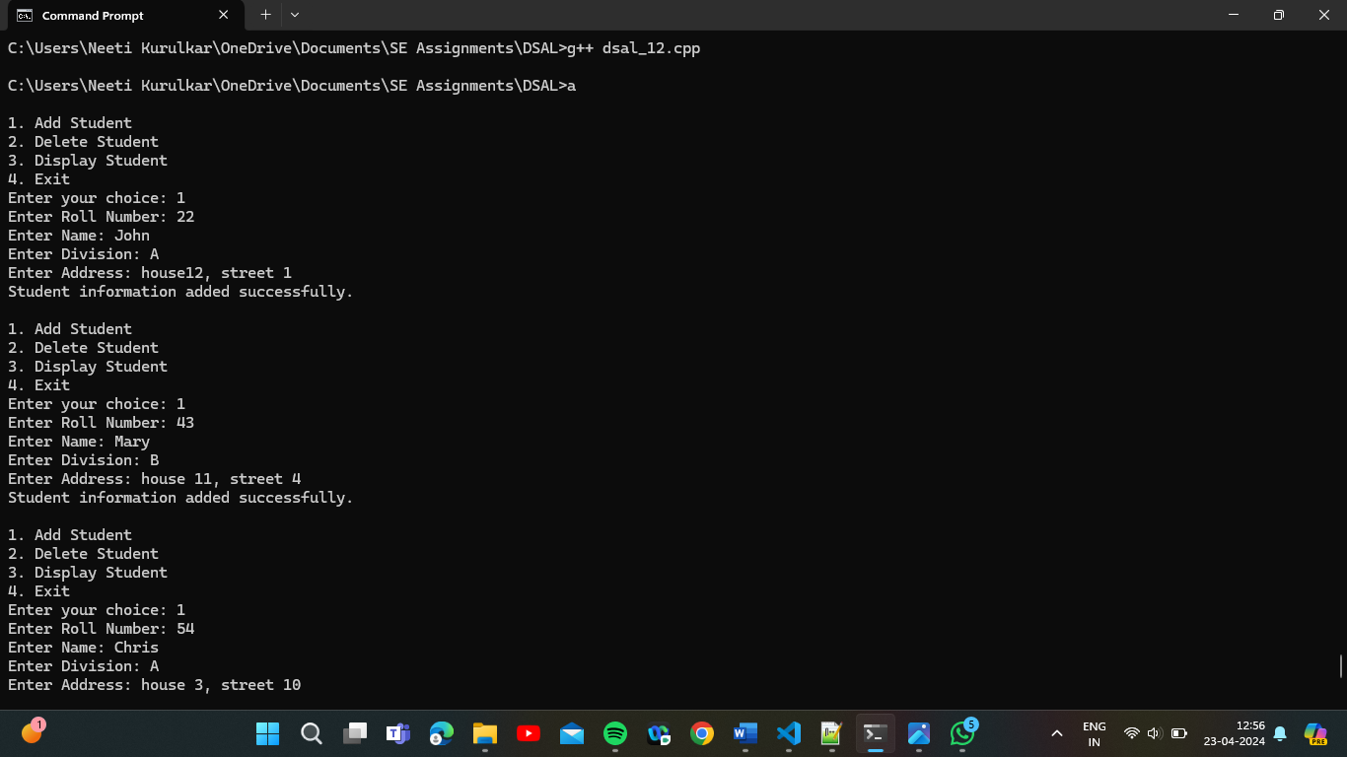

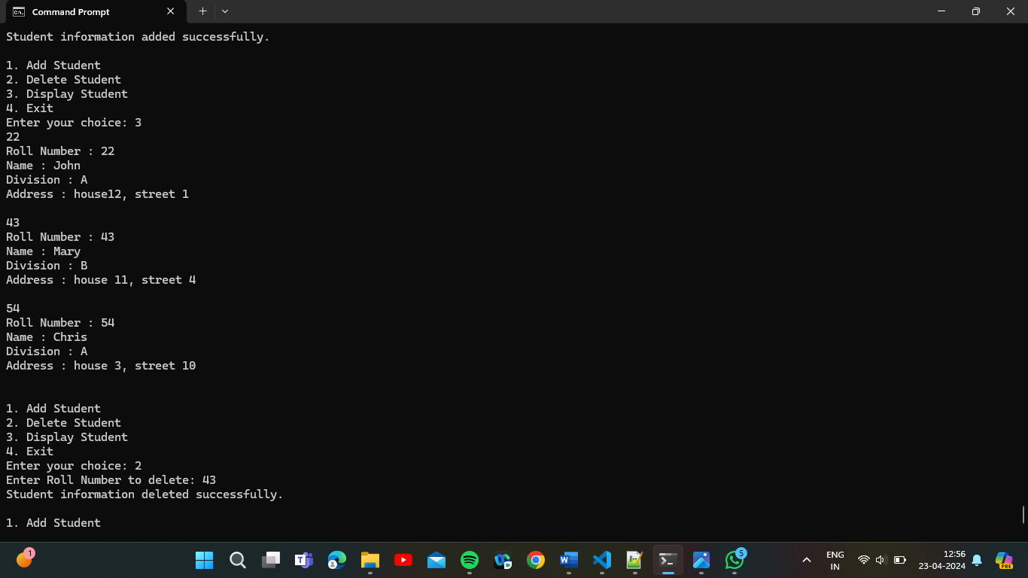

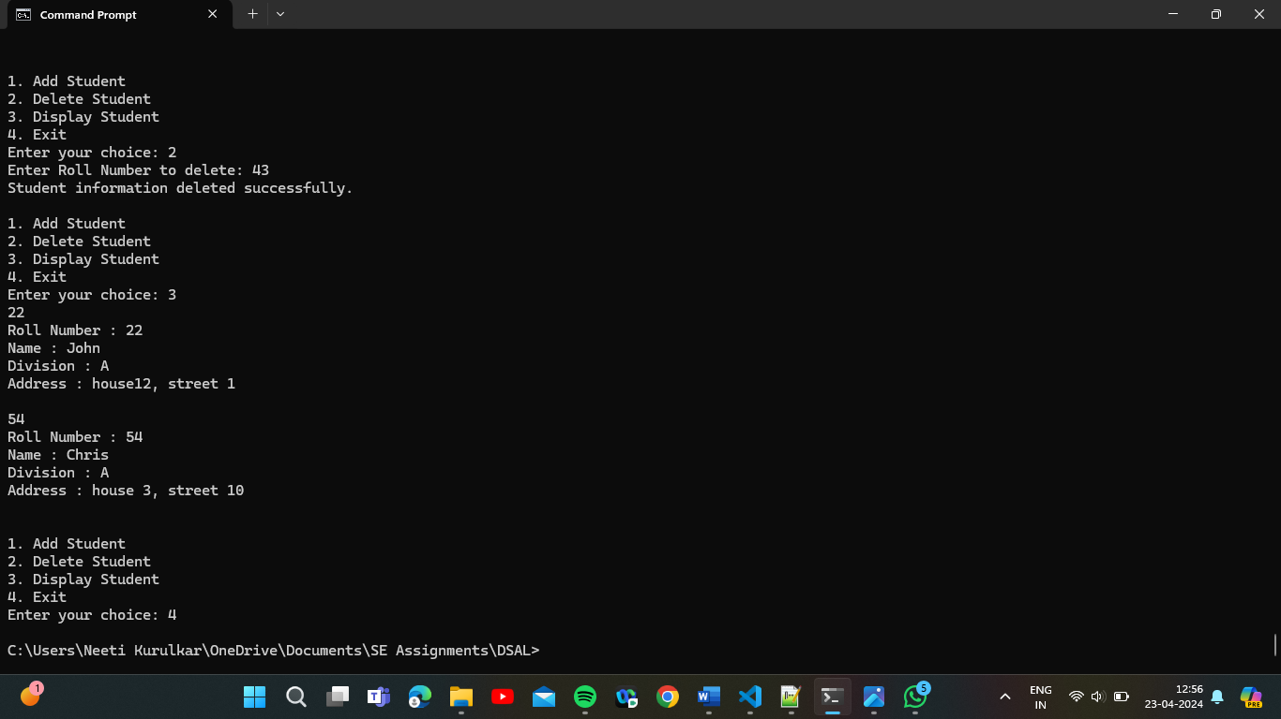

File after program execution :

